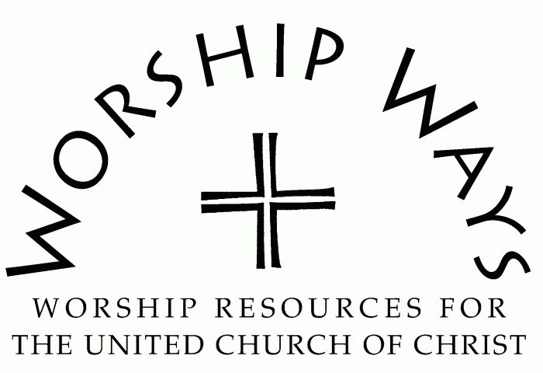
September 3, 2023
Fourteenth Sunday After Pentecost
“Confrontation”

Call to Worship
One: Give thanks to the Holy One!
Many: The God of our ancestors is with us!.
One: Give thanks to the Holy One!
Many: We call upon the name of our God, and our God responds.
One: Give thanks to the Holy One!
Many: The steadfast and faithful love of our God lasts forever!.

Invocation
Eternal God, when we search for you, we find you. When we seek you, we find you seeking us. Your presence among us changes our circumstances and our lives. We honor and worship you as an act of devotion and discipleship. Infuse us with your Spirit that our witness and ministry may be a testimony to your everlasting love. Amen.

Prayer for Transformation and New Life
Forgiving God, we acknowledge that repentance opens the door to forgiveness and transformation. We turn from our desire for comfort over compassion, easy solutions or challenging resolution, and avoidance over confrontation. We need your strength, fortitude, and conviction to overcome our fear of loss to make room for the gains of new life for ourselves and our neighbors through our generous and sacrificial living.

Words of Grace
God is faithful to forgive and to redeem. God will sustain us through the hard work of confronting truth about ourselves, our communities, and our world. Receive the companionship of the Holy Spirit who leads and guides us in all truth.

Invitation to Generosity
Jesus posed the question, “For what will it profit them if they gain the whole world but forfeit their life?” When we consider the gifts we give and receive, we remember that Creator is also Source. Let us give generously of the abundance of our lives so that the world may be made better and God’s kindom may come nearer.

Prayer of Dedication and Thanksgiving
Generous God, thank you for the seeding and inspiring generosity in us. May these gifts be a blessing to the ministry of this church. Multiply them and make us fruitful and faithful steward of our time, talent, and treasure.

Benediction
May our lives serve as beacons of hope, compassion, and possibility as we go with God on the journey of truth.

Confrontation: Service Prayers for the Fourteenth Sunday after Pentecost were written by The Rev. Dr. Cheryl A. Lindsay, Minister for Worship and Theology, United Church of Christ.

