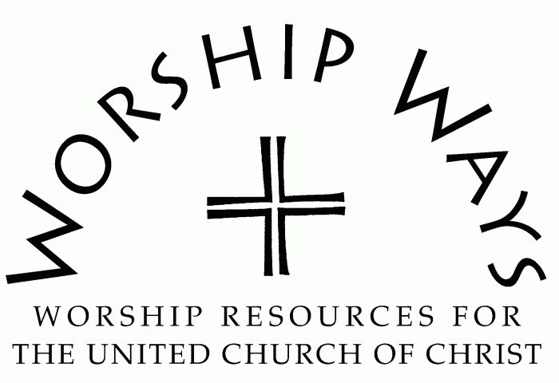
September 17, 2023
Sixteenth Sunday After Pentecost
“Forgiveness”

Call to Worship (Inspired by Psalm 103)
One: Bless the Holy One with our whole selves. Praise the Maker of our being!
Many: Remember the mighty deeds and the good works of our God.
One: The Sovereign One endows us with many gifts and equips us to do good work.
Many: Remember the mighty deeds and the good works of our God.
One: Holy Love entered the world without condemnation but with grace and forgiveness, mercy and compassion, redemption and restoration.
Many: Hallelujah! We give thanks for the mighty deeds and the good works of our God!

Invocation
God who calls, it is you who gathers us together and forms us as a community. It is you who makes us uniquely individual and who designs us for companionship. Let us journey together this day in your presence reminded of our interdependence with one another. May we see your glory and be inspired to demonstrate your goodness and care through our lives. Amen.

Prayer for Transformation and New Life
God of grace, we need your strength in our weakness. We confess that we can be judgemental and hyper-critical of our neighbors, family, and friends. We project our own shortcomings on others in order to deflect attention from our mistakes. We withhold and condition forgiveness, mercy, and grace from those who wrong us at the same time we seek it for the wrongs we have done. Even still, we struggle to forgive ourselves. You have shown us the better way. Help us to follow your path–receiving and extending forgiveness in a world in need of an infusion of grace for transformation. In your mercy, O God, hear our prayer, and let us forgive as you forgive. Amen.

Words of Grace
Beloved, grace has always been part of God’s relationship with humanity. God does not want you condemned or held captive by unresolved anger leading to bitterness. Rather, Creator desires you to be released as both forgiven and forgiver so that all may live a life that is whole, free, and flourishing.

Invitation to Generosity
Romans 14:7 tells us, “We do not live to ourselves, and we do not die to ourselves.” We are in covenant with God and joined in community with one another. Let us give of our resources as those who live for the good and well-being of all.

Prayer of Dedication and Thanksgiving
Merciful God, receive our humble offerings as a testimony to your provision and a demonstration of our love. May they be magnified and multiplied for the benefit of our community and all creation.

Benediction
May the love of God assure you, the hope of God guide you, and the peace of God sustain you as you go receiving and extending God’s grace in the world.

Forgiveness: Service Prayers for the Sixteenth Sunday after Pentecost were written by The Rev. Dr. Cheryl A. Lindsay, Minister for Worship and Theology, United Church of Christ.

